
Background
- Music is an accessible resource, found to be beneficial for health and wellbeing. Listening to music is identified as a coping technique and resource.
- While listening to music is considered as a resource, coping or distraction strategy for voice hearers, research findings are mixed and little detail is known about how voice hearers make use of music
- Heavy metal music, specifically, may offer protective roles for its fans, however the role of heavy metal music for voice hearers has not yet been explored.
- This study addresses a gap in understanding the subjective experiences of voice hearers who are heavy metal fans.
Aim of the Research Study: The aim was to develop a conceptual framework to improve psychological understanding of what heavy metal music offers voice hearers, including the role of heavy metal music, how it is used and what it provides for voice hearers.
Method: Constructivist Grounded Theory was the approach used, aiming to develop a theory/model that was grounded in the data collected throughout the study.
Participants and Data Collection: Six participants (adult voice hearers, identifying as heavy metal fans or regular listeners) took part in interviews sharing their perspectives about what heavy metal music offers them, and how they make use of listening to heavy metal music within their lives.
Ari Azmoodeh, Doctorate in Clinical Psychology, Teesside University
Acknowledgements – Huge thank you to the participants who took part, and the research supervisors (Dr (SJ) Ash Summers, Dr Kate Quinn).

Research Questions
- In what ways do voice hearers use heavy metal music, and what does it provide?
- How does heavy metal music use interact with experiences of hearing voices?
- What are the underlying psychological and social processes involved?
Results: Eight Core Categories shown on the diagram below, provide an explanation of the various processes related to how voice hearers make use of heavy metal music; outlining the key functions and uses of metal music and what it provides for them.
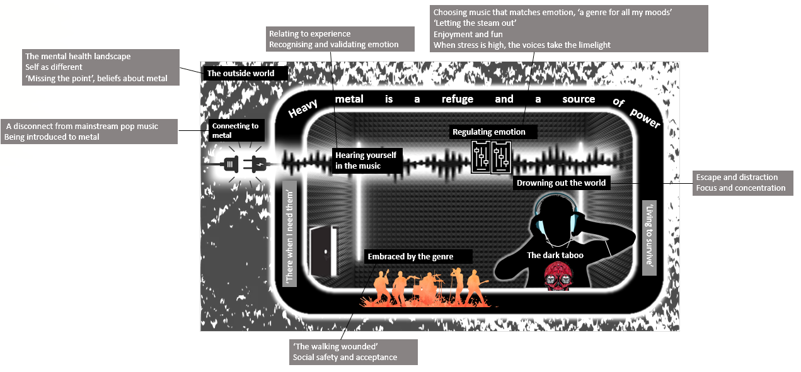
- This is the first qualitative study focused on voice hearers' specific uses of heavy metal music.
- Heavy metal provides participants a multifaceted 'refuge' providing safety and power identified as integral for hope, motivation and survival. The model highlights the role of connecting to the sound and experiences, validation, emotion regulation, escape and focus, a recognition of topics and experiences that society may view as ‘taboo’, as well as finding acceptance and belonging.
- The results and end model emphasises the role of personal meaning and the diverse functions of metal music beyond a focus on distraction and a reduction of voice hearing experiences.

Understanding voice hearers’ uses of heavy metal music and what it provides.
“It’s a refuge. So you tend to wrap yourself in it more, so you’re sort of burying yourself deeper in the music”
Understanding voice hearers’ uses of heavy metal music and what it provides.
“It’s a refuge. So you tend to wrap yourself in it more, so you’re sort of burying yourself deeper in the music”

